**Software Requirements Specifications (SRS)**

**ERP Solution for Lakhsma Sweater Ltd.**

REFERENCE: GW/ERP/SRS/Time & Action

**Version: 1.0**

**Date of Release: May 19, 2016**



**Genweb2 Limited**

TK Bhaban (11th Floor),

13 KaziNazrul Islam Avenue,

Kawran Bazar, Dhaka 1215, Bangladesh

web: [http://www.genweb2.com](http://www.genweb2.com/)

**Contents**

Document Release History 4

1.0 Introduction 5

1.1 Purpose of SRS 5

2.0 Procurement 6

2.1 Overview 6

2.2 Functional features of Time & Action modules are given below 6

2.3 Time & Action Process flow 6

2.4 User Class 7

3.0 Process Flow: 8

3.1 Time & Action Process Flow 8

3.2 Task Creation Process 9

3.3 Task Template Creation Process 10

3.4 Task Template Attachment Process 11

3.5 Task Generation Process 12

3.6 Task Distribution Process 13

3.7 Task Completion Process 14

3.8 Task Monitoring Process 15

3.9 Task Assignee Alteration Process 16

4.0 USE CASE Diagram 17

4.1 Task Template Creation 17

4.2 Task Generation, Distribution & Assignee Alteration 18

4.3 Task Completion 19

4.4 Task Monitoring 20

5.0 USE CASE Details 21

5.1 UC/T&A/001/Create Task 21

5.2 UC/T&A/002/Update Task 22

5.3 UC/T&A/003/Create Task Template 23

5.4 UC/T&A/004/Update Task Template 24

5.5 UC/T&A/005/Attach Task Template 24

5.6 UC/T&A/006/Generate Task 26

5.7 UC/T&A/007/Distribute Task 26

5.8 UC/T&A/008/Seen Task 27

5.9 UC/T&A/009/Commit Task 28

5.10 UC/T&A/010/Complete Task 28

5.11 UC/T&A/011/Monitor Task 29

5.12 UC/T&A/012/Alter Task 30

6.0 Time & Action Mock-up 32

6.1 Task Creation 32

6.2 Task template Creation 33

6.3 Task Template Attachment 34

6.4 Task Manager 34

6.5 My Task 35

6.6 Task Assignee Alteration 35

Document Release History

| Sl. No. | Version Number | Release Date | Prepared By | Reviewed By | Approved By | Reasons for New Release |
| --- | --- | --- | --- | --- | --- | --- |
| 1 | 1.0 | 19th May, 2016 | Md. Assalatuzzaman |  | N/A | 1st Release |
|  |  |  |  |  |  |  |

# Introduction

## Purpose of SRS

The purposes of this SRS are to clearly identify the customer requirements and provide a detailed document. The customer will review the document and approve/make change as required. It will also help the review team to be able to validate whether the customer requirements has been fulfilled.

The SRS will also help the Analyst and Designer to understand and track the Requirements for the proposed system. It will also identify a set of requirements for the Development of the project. The SRS helps to describe the behavior of the system to be developed.

# Procurement

## Overview

Time & Action module is for manage tasks in a vast way. Complete task level monitoring and Critical Path Analysis are handled through this module. Different templates with predefined tasks and relationships may be kept in the system. The system provides enough flexibility to the user to create Templates for different Product Types and Order Lead Times Woven, Woven with Wash, Knit, Sweater, etc. Upon attaching the templates at Style or Order level, the system populates the start & end dates against individual task. Against the relevant predefined task for the Order, the concerned person assigned to the task needs to put the commitment date.

The system provides Critical Path for an Order and also task to do list for each individual employee and keeps track of the completion status. Any deviation on the Critical Path can be immediately picked up. The system also sends out email reminders for upcoming critical tasks and alerts for missed tasks. Through this module, the system provides some important information which is very much helpful for employee’s performance appraisal.

Different Predefined Task Templates can be maintained by Buyer, Lead Time, etc. When Orders are confirmed, appropriate Template can be attached to easily create the required Tasks.

Assigning Order Tasks to Employees ensures no task is left unattended.

An Employee can see and act upon all his/her Assigned tasks from one single place.

Regular follow up reminders from the System ensures that no task is left unattended which goes a long way to completing an Order on time.

System facilitates the Top Management to intervene on Critical Tasks before they go beyond manageable state.

Top Management can easily check the status of all Tasks for an Order, thus enabling them to address Buyer inquiries about existing Orders.

On time Completion of Assigned tasks by Individual Employee can be reflected in the Employee's Performance Appraisal.

## Functional features of Time & Action modules are given below

* Task Creation Option with dependency and Calculation Logic
* Task Template facility to use the Template as require
* System automated Task generation process
* Real time notification for Task generation and Status update
* Easy Task Monitoring Facility
* Task Assignee Alteration Facility

## Time & Action Process flow

* Create Task
* Create Task Template
* Attach Task Template
* Generate & Distribute Task (System Generated)
* Task Status Update Option
* Task Assignee Alteration (If Require)

## User Class

|  |  |  |
| --- | --- | --- |
| User Class/ Actor | Characteristics | Responsibilities |
| Merchandiser | * Create Task * Create Task Template * Attach Task Template | * Add, modify documents * Maintain other documents related information |
| T&A Administrator | * Generate Task * Distribute Task * Alter Task | * Add, modify documents * Maintain other documents related information |
| Task Assignee | * View Task * Update Task Status | * Add, modify documents * Approve document * Add necessary comments during approval if required |
| Management | * Task Monitoring | * Add, modify documents * Approve document * Provide necessary comments during approval if required |
| Super User | * Create Task * Create Task Template * Attach Task Template * Generate Task * Distribute Task * Alter Task * View Task * Update Task Status * Task Monitoring | * Add, modify documents * Approve document * Provide necessary comments during approval if required |

# Process Flow:

## Time & Action Process Flow

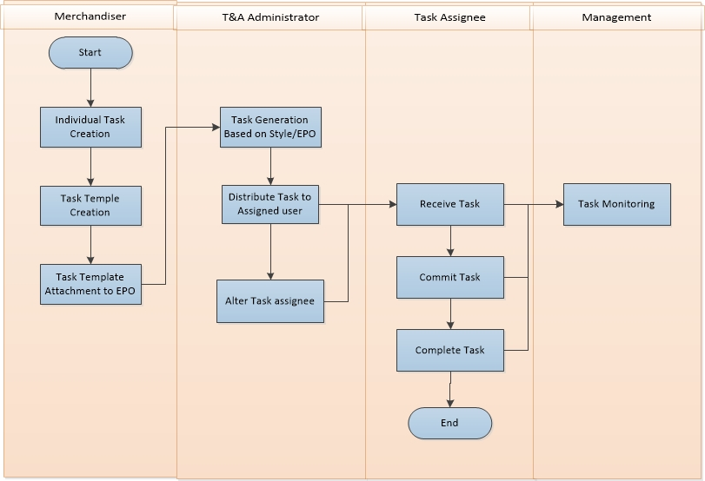

**Raise Indent Process Description:**

* Merchandiser Create different type of Tasks according to task type and task generation logic
* Merchandiser create Task Template (Set of Tasks together based on order/product/Buyer type)
* Merchandiser Attach the Task Template To relevant Export PO
* T&A Administrator will generate Task (It is a system automated process to generate task by logic declared while creating task and amendment in template and attachment) with the assigned person name.
* Task will be distributed automatically to the assigned person along with Start Date & Deadline.
* Assigned person will be notified for his/her new tasks.
* Assigned person will commit his/her date for starting and end date of that task.
* Assigned person will complete the task.
* Management will monitor the task traffic.
* Management & Stakeholders will be notified for any overdue task
* T&A Administrator may alter the task assignee if require and related stakeholders will be notified.

## Task Creation Process

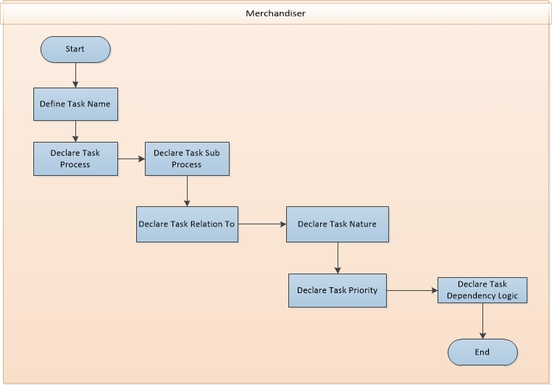

**Task Creation Process**

* Define Task Name
* Declare Task Process
* Declare Task Sub Process
* Declare Task Relation Factor
* Declare the Task Nature
* Declare Task Priority
* Declare Task Dependency Logic

## Task Template Creation Process

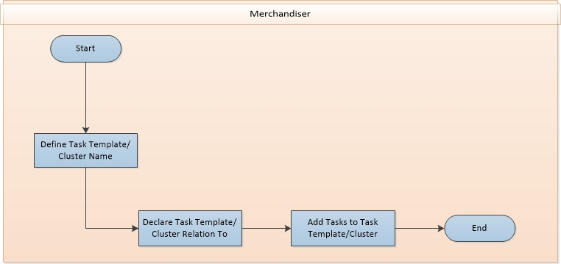

**Task Template Creation Process**

* Define Task Template/Cluster Name
* Declare Task Template Relative Factor
* Add Tasks to Task Template

## Task Template Attachment Process

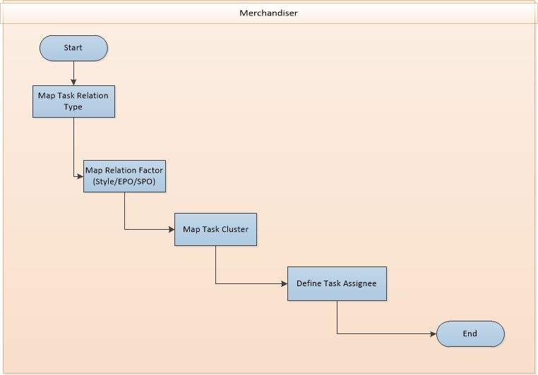

**Task Template Attachment Process**

* Map Task Relative Factor
* Define the specific Relative Factor (Style/EPO/SPO)
* Map Task Cluster
* Define Task Assignee

## Task Generation Process

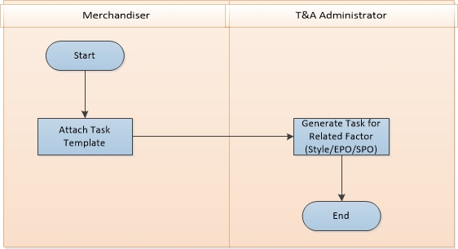

**Task Generation Process**

* Attach Task Template to specific Relative Factor (Style/EPO/SPO)
* Generate Tasks for the specific Relative Factor

## Task Distribution Process

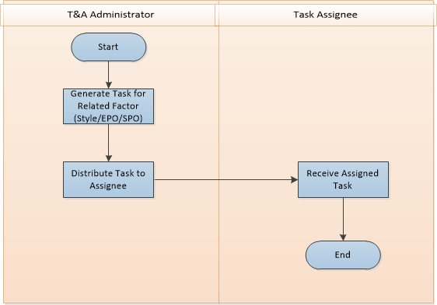

**Task Distribution Process**

* Generate Task for the specific Relative Factor
* Distribute Task to the Assignee
* Task Assignee receive the assigned Task

## Task Completion Process

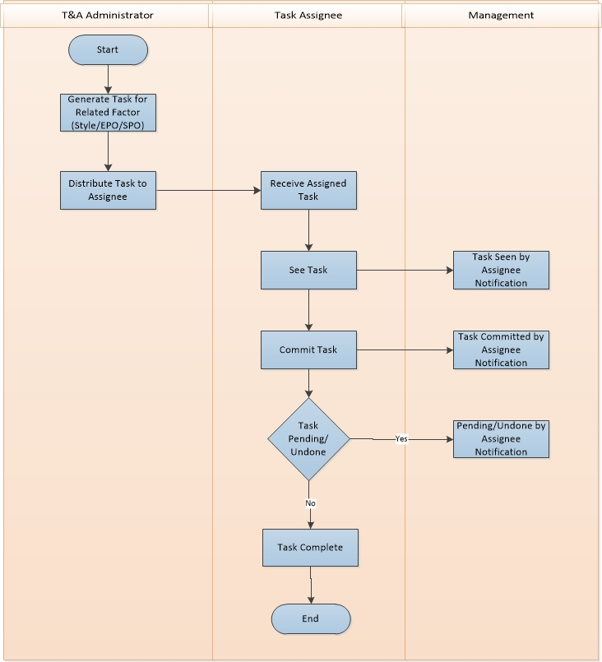

**Task Completion Process**

* Generate Task for specific Relative Factor
* Distribute Task to the Assignee
* Assignee receive the assigned Task
* Assignee view the Task details
* Merchandiser, T&A Administrator, Management get notification of Task Status
* Assignee Commit a date for task completion
* Merchandiser, T&A Administrator, Management get notification of Task Status
* Assignee Complete the assigned Task
* Merchandiser, T&A Administrator, Management get notification of Task Status

## Task Monitoring Process

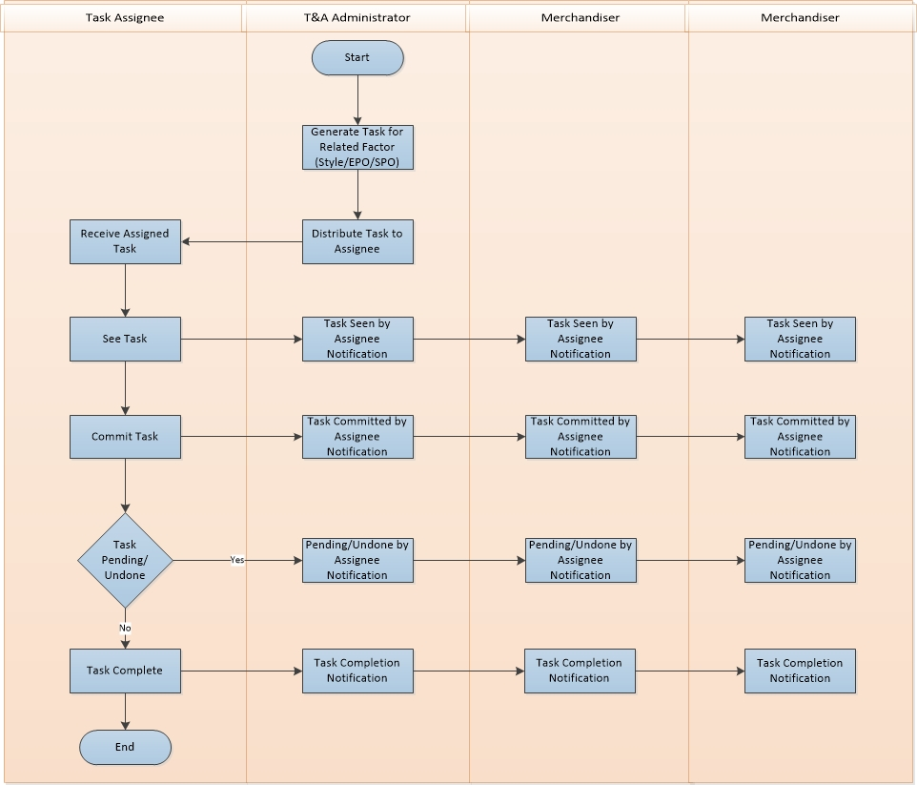

**Task Monitoring Process**

* Generate Task for specific Relative Factor
* Distribute Task to the Assignee
* Assignee receive the assigned Task
* Assignee view the Task details
* Merchandiser, T&A Administrator, Management get notification of Task Status
* Assignee Commit a date for task completion
* Merchandiser, T&A Administrator, Management get notification of Task Status
* Assignee Complete the assigned Task
* Merchandiser, T&A Administrator, Management get notification of Task Status

## Task Assignee Alteration Process

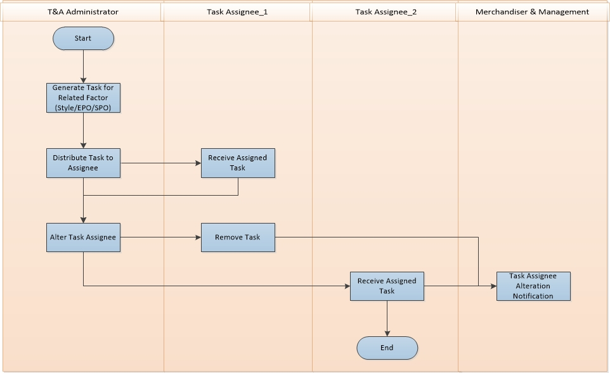

**Physical Inventory Process Description**

* Generate Task for specific Relative Factor
* Distribute Task to the Assignee
* Assignee receive the assigned Task
* T&A Administrator Alter the Task Assignee
* Task get removed from the earlier Assignee
* Altered Task assignee follow the regular Task completion process

# USE CASE Diagram

## Task Template Creation

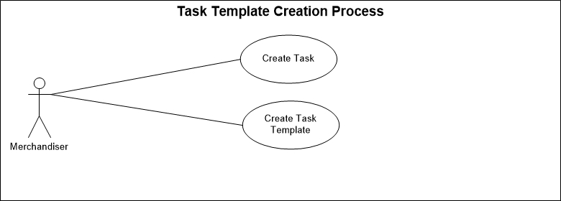

Fig: Task Template Creation

## Task Generation, Distribution & Assignee Alteration

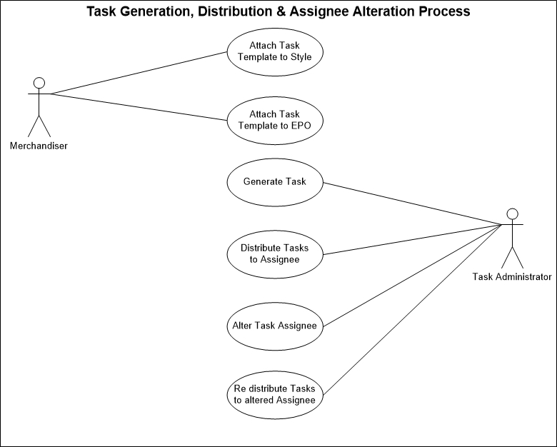

Fig: Task Generation, Distribution & Assignee Alteration

## Task Completion

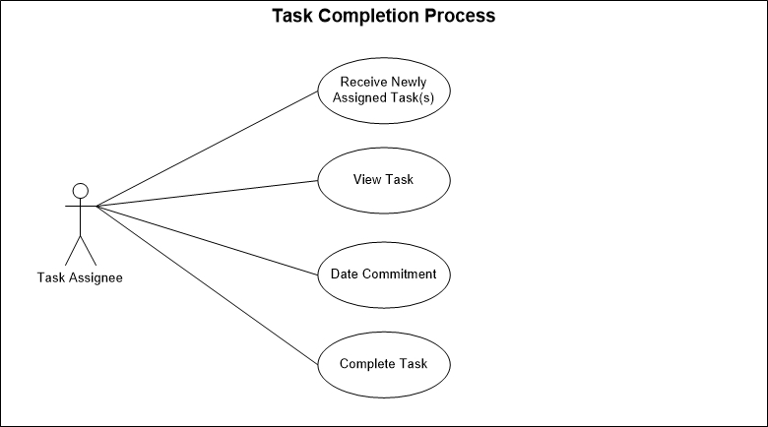

Fig: Task Completion

## Task Monitoring

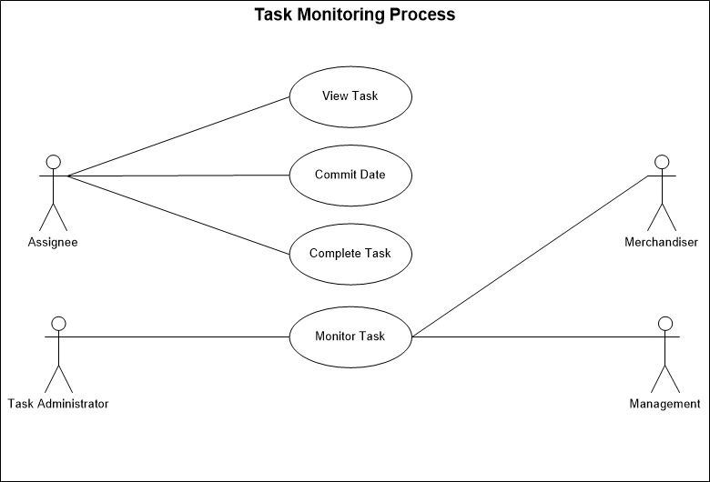

Fig: Task Monitoring

# USE CASE Details

## UC/T&A/001/Create Task

|  |  |
| --- | --- |
| Use Case ID: UC/T&A/001 | |
| Use Case Name**: Create Task** | |
| Created By: **GenWeb2 Ltd.** | Date Created: 16 May, 2016 |
| Actors: | * Merchandiser |
| Trigger: | * When Merchandiser Need to create a new Task for the Operation |
| Business Rule | * Merchandiser Create a Task with all task generation logic. * Task will be added in Task Template * Task Template will be attached with the related factor (Style/EPO/SPO) * Task will be generated for the Attached related factor as per defined logic |
| Description: | Merchandiser Create any new task with task generation logic which will be require for executing any order. That task will be added in the Task template along with the other related tasks. After attaching the Task Template to the related factor (Style/EPO/SPO) task will be generated for the related factor as per given logic |
| Frequency of Use | * Medium |
| Preconditions | * Task Process must exist in system * Task Sub Process Must Exist in System |
| Post Conditions | * Appropriate message will be displayed after each entry being saved / updated. |
| Assumption | * N/A |
| Goal | Create Task in System |
| Normal Flow | * Task will be created by Merchandiser * Task generation logic will be defined here. * Task Name will be defined by merchandiser * User will select the Related Process * User will select the related Sub Process * User will select the Task Related Factor (Style/EPO/SPO) * User will Select the Task Type whether Pre Production or Post Production * User will defined whether it is milestone Task or not * Declare Task Dependency Logic:   + If it is an Independent Task (No way dependent to any date or any other task) then user will select the dependency as Independent and Standard Days for completion of the Task will be declared.   + Is the task is dependent on a predefined date then user will select the Dependency type Predefined Event Date. Event Date name must be selected. Lag date from the event date will be defined with the value of calculation logic like Backward or forward must be selected. Standard days for completion the task will be defined here.   + If the task is dependent on any other task then the user will select the Dependency Type Presiding Task Dependent. Lag Days from the dependent Task will be declared here with the Calculation Type S-S (Start to Start) or E-S (End to start). Standard days of completion of the task will be defined here. |
| Alternate Flow | N/A |
| Exception | * Proper message should be displayed if Task can’t be saved. * Proper message should be displayed if any master or dependent data is missing or not found. * Appropriate message should be displayed if mandatory fields are not filled. * Any system exception/Application exception should be handled centrally with proper user message during the page browse/save/update/view operations. |
| Cross Reference | * N/A |

## UC/T&A/002/Update Task

|  |  |
| --- | --- |
| Use Case ID: UC/T&A/002 | |
| Use Case Name**: Update Task** | |
| Created By: **GenWeb2 Ltd.** | Date Created: 16 May, 2016 |
| Actors: | * Merchandiser |
| Trigger: | * When any Task need to be updated for modify any information. |
| Business Rule | * Merchandiser has created the Task * Merchandiser will update the Task logic |
| Description: | If any Task need to be updated for further operation |
| Frequency of Use | Medium |
| Preconditions | * Task must exist in System. |
| Post Conditions | * Appropriate message will be displayed after each entry being saved/ updated. * Will be available for edit/modify again. * Task will be Updated with the updated information |
| Assumption | * N/A |
| Goal | Update the Task in System |
| Normal Flow | * Merchandiser has already created the Task. * For any reason Merchandiser need to update the task ;for further operation. |
| Alternate Flow | * N/A |
| Exception | * Proper message should be displayed if Task can’t be updated * Appropriate message should be displayed if mandatory fields are not filled. * Any system exception/application exception should be handled centrally with proper user message during the page browse/save/update/view operations. |
| Cross Reference | * Use Case ID: UC/T&A/001 |

## UC/T&A/003/Create Task Template

|  |  |
| --- | --- |
| Use Case ID: UC/T&A/003 | |
| Use Case Name**: Create Task Template** | |
| Created By: **GenWeb2 Ltd.** | Date Created: 16 May, 2016 |
| Actors: | * Merchandiser |
| Trigger: | * When Merchandiser create any Task Template for a set of Task require to execute any Order |
| Business Role | * Merchandiser create individual Task then Merchandiser create any Task Template for a set of Task require to execute any Order |
| Description: | Merchandiser create tasks and then create Task Template for a set of task to execute any order |
| Frequency of Use | * Medium |
| Preconditions | * Tasks must be exist in System |
| Post Conditions | * Task Template will be saved * Task Template will be available to attach with the relative factor (Style/EPO/SPO) |
| Assumption | * N/A |
| Goal | To Create Task Template in System |
| Normal Flow | * Tasks already created in system by the Merchandiser * In the Task Template Set of Tasks will be added. * Task Cluster/Template name will be defined by the User * Task Relation Factor will be selected (Style/EPO/SPO) * Only same related factor task will be available to add in the Template. * If task Template Relation Factor modified then all the added tasks will be removed. * User will select the require tasks. * If user select any task what is based on presiding task Dependent then user must select the dependent task name from the upper tasks. First task from the list can’t be a presiding Task Dependent one. * User will save the Task Template |
| Alternate Flow | * N/A |
| Exception | * Proper message should be displayed if Task Template can’t be saved * Appropriate message should be displayed if approval not possible. * Any system exception/application exception should be handled centrally with proper user message during the page browse/save/update/view operations. |
| Cross Reference | * Use Case ID: UC/T&A/001 |

## UC/T&A/004/Update Task Template

|  |  |
| --- | --- |
| Use Case ID: UC/T&A/004 | |
| Use Case Name**: Update Task Template** | |
| Created By: **GenWeb2 Ltd.** | Date Created: 16 May, 2016 |
| Actors: | * Merchandiser |
| Trigger: | * When any Task Template needs to be updated for modify any information. |
| Business Role | * Merchandiser has created the Task Template * Merchandiser will update the Task Template |
| Description: | If any Task Template needs to be updated for further operation |
| Frequency of Use | Medium |
| Preconditions | * Task Template must exist in System. |
| Post Conditions | * Appropriate message will be displayed after each entry being saved/ updated. * Will be available for edit/modify again. * Task Template will be Updated with the updated information |
| Assumption | * N/A |
| Goal | Update the Task Template in System |
| Normal Flow | * Merchandiser has already created the Task Template. * For any reason Merchandiser need to update the task Template for further operation. |
| Alternate Flow | * N/A |
| Exception | * Proper message should be displayed if Task Template can’t be updated * Appropriate message should be displayed if mandatory fields are not filled. * Any system exception/application exception should be handled centrally with proper user message during the page browse/save/update/view operations. |
| Cross Reference | * Use Case ID: UC/T&A/003 |

## UC/T&A/005/Attach Task Template

|  |  |
| --- | --- |
| Use Case ID: UC/T&A/005 | |
| Use Case Name**: Attach Task Template** | |
| Created By: **GenWeb2 Ltd.** | Date Created: 16 May, 2016 |
| Actors: | * Merchandiser |
| Trigger: | When Merchandiser attach any task to any related factor (Style/EPO/SPO) |
| Business Role | * Merchandiser already created Tasks. * Merchandiser has created the Task Template. * Now Merchandiser will attach the Task Template to The related factor (Style/EPO/SPO) |
| Description: | Merchandiser has create the Task Template for a set of Task which is require to execute any order. Then Merchandiser will attach the Task template to the Related Factor (Style/EPO/SPO) |
| Frequency of Use | * Medium |
| Preconditions | * Task Template must exist in System * Related Factor (Style/EPO/SPO) must exist in System. * Assignee name must exist in System |
| Post Conditions | * Task Template will be attached with the declared related factor entity. |
| Assumption | * N/A |
| Goal | Attach Task Template to the Related Factor (Style/EPO/SPO) |
| Normal Flow | * User will select the Relation Factor. * User will select the relation factor value * User will select the Task Template/Cluster. * User will select the assignee name for each Task. * User will same the Task Template Attachment |
| Alternate Flow | * N/A |
| Exception | * Proper message should be displayed if Task Template can’t be attached. * Any system exception/Application exception should be handled centrally with proper user message during the page browse/save/update/view operations. |
| Cross Reference | * Use Case ID: UC/T&A/004 |

## UC/T&A/006/Generate Task

|  |  |
| --- | --- |
| Use Case ID: UC/T&A/006 | |
| Use Case Name**: Generate Task** | |
| Created By: **GenWeb2 Ltd.** | Date Created: 16 May, 2016 |
| Actors: | * T&A Administrator (System) |
| Trigger: | * When Tasks will be generated after Task Template Attachment |
| Business Role | * To generate Task for any Style/EPO/SPO |
| Description: | * Tasks will be generated after attaching any Task Template to its related Factor. System will generate the task in favor of Task Administrator |
| Frequency of Use | * Medium |
| Preconditions | * Task template must be attached with the relative factor |
| Post Conditions | * All Tasks will be generated for the relative factor as per Task template and Task generation logic. * Task will be distributed to the assigned user. |
| Assumption | * N/A |
| Goal | To Generate Tasks for any Relative Factor (Style/EPO/SPO) |
| Normal Flow | * It is a System Generated Process. * When Merchandiser attached any Task Template to any relative factor then System generate all the tasks as per task Template and Task generation logic. |
| Alternate Flow | * N/A |
| Exception | * Proper message should be displayed if Task can’t be generated. * Any system exception/Application exception should be handled centrally with proper user message during the page browse/save/update/view operations. |
| Cross Reference | * Use Case ID: UC/T&A/005 |

## UC/T&A/007/Distribute Task

|  |  |
| --- | --- |
| Use Case ID: UC/T&A/007 | |
| Use Case Name**:** Distribute Task | |
| Created By: **GenWeb2 Ltd.** | Date Created: 16 May, 2016 |
| Actors: | * Task Administrator |
| Trigger: | * When any Task distribute to the Assigned user/Employee |
| Business Rule | * Task has been generated and distributing to the Assigned User/Employee |
| Description: | System generate the Task in favor of the T&A administrator and distribute all the Tasks to the assigned User/Employee. |
| Frequency of Use | * Medium |
| Preconditions | * Task Template must be attached * Task must be generated |
| Post Conditions | * Assigned user/Employee will be notified for the newly assigned task with the task details * Related Merchandiser/Management/T&A Administrator will be notified the Task has been distributed to the assigned User/Employee |
| Assumption | * N/A |
| Goal | To Distribute Task to the Assigned User/Employee |
| Normal Flow | * System generate tasks based on Task Template Attachment information * System Distribute Tasks to all assigned User/Employee |
| Alternate Flow | * N/A |
| Exception | * Proper message should be displayed if Task can’t be distributed to the assigned User/Employee * Any system exception/Application exception should be handled centrally with proper user message during the page browse/save/update/view operations. |
| Cross Reference | * Use Case ID: UC/T&A/006 |

## UC/T&A/008/Seen Task

|  |  |
| --- | --- |
| Use Case ID: UC/T&A/008 | |
| Use Case Name: Seen Task | |
| Created By: **GenWeb2 Ltd.** | Date Created: 16 May, 2016 |
| Actors: | * Task Assignee |
| Trigger: | * When Any Task Assignee view the distributed task |
| Business Rule | * T&A Administrator generate the tasks and distribute to the related assignee. * Task Assignee view the Task details |
| Description: | Task Assignee view the task details and Management and T&A Admin get the notification that Assignee has already viewed the Task details so it minimize the scope the keep any task unattended. |
| Frequency of Use | * Medium |
| Preconditions | * + - * Task Must be Generated       * Task must be distributed to the Assignee |
| Post Conditions | * + - * Task Status will be updated as “Seen”       * Merchandiser, T&A Administrator, Management will be notified that Assignee has seen the Task |
| Assumption | * N/A |
| Goal | To update the Task status from Pending to Seen |
| Normal Flow | * T&A Administrator generated the Task * T&A Administrator distributed the Task to assignee * Assignee View the Task details * Task status will be updated as Seen from pending |
| Alternate Flow | * N/A |
| Exception | * Any system exception/Application exception should be handled centrally with proper user message during the page browse/save/update/view operations. |
| Cross Reference | * Use Case ID: UC/T&A/007 |

## UC/T&A/009/Commit Task

|  |  |
| --- | --- |
| Use Case ID: UC/T&A/009 | |
| Use Case Name**: Commit Task** | |
| Created By: **GenWeb2 Ltd.** | Date Created: 16 May, 2016 |
| Actors: | * Task Assignee |
| Trigger: | * When Any Task Assignee commit a start date for the distributed task |
| Business Rule | * T&A Administrator generate the tasks and distribute to the related assignee. * Task Assignee view the Task details * Task Assignee commit a start date for the assigned task |
| Description: | Task Assignee commit a start date for the task and Management and T&A Admin get the notification that Assignee has already committed a start date for the task, so if there is any delay to start the task management can take quick decision to resolve it. |
| Frequency of Use | * Medium |
| Preconditions | * + - * Task Must be Generated       * Task must be distributed to the Assignee       * Task Must be viewed by the Assignee |
| Post Conditions | * + - * Task Status will be updated as “Committed”       * Merchandiser, T&A Administrator, Management will be notified that Assignee has committed a start date |
| Assumption | * N/A |
| Goal | To update the Task status from Seen to Committed |
| Normal Flow | * T&A Administrator generated the Task * T&A Administrator distributed the Task to assignee * Assignee View the Task details * Assignee Commit a start date for the task * Task status will be updated as Committed from Seen |
| Alternate Flow | * N/A |
| Exception | * Proper message should be displayed if Task Commitment date can’t be saved * Any system exception/Application exception should be handled centrally with proper user message during the page browse/save/update/view operations. |
| Cross Reference | * Use Case ID: UC/T&A/008 |

## UC/T&A/010/Complete Task

|  |  |
| --- | --- |
| Use Case ID: UC/T&A/010 | |
| Use Case Name**: Complete Task** | |
| Created By: **GenWeb2 Ltd.** | Date Created: 16 May, 2016 |
| Actors: | * Task Assignee |
| Trigger: | * When Any Task Assignee complete the distributed task |
| Business Rule | * T&A Administrator generate the tasks and distribute to the related assignee. * Task Assignee view the Task details * Task Assignee commit a start date for the assigned task * Task Assignee Complete the Assigned Task |
| Description: | Task Assignee Complete any assigned task and update the status of the task from Committed to Completed |
| Frequency of Use | * Medium |
| Preconditions | * + - * Task Must be Generated       * Task must be distributed to the Assignee       * Task Must be viewed by the Assignee       * Task Assignee must commit a Start date for the Task |
| Post Conditions | * + - * Task Status will be updated as “Completed”       * Merchandiser, T&A Administrator, Management will be notified that Assignee has Completed the Assigned Task |
| Assumption | * N/A |
| Goal | To update the Task status from Committed to Completed |
| Normal Flow | * T&A Administrator generated the Task * T&A Administrator distributed the Task to assignee * Assignee View the Task details * Assignee Commit a start date for the task * Task Assignee Complete the assigned Task * Task status will be updated as Completed from Committed |
| Alternate Flow | * N/A |
| Exception | * Proper message should be displayed if Task status can’t be updated as Completed * Any system exception/Application exception should be handled centrally with proper user message during the page browse/save/update/view operations. |
| Cross Reference | * Use Case ID: UC/T&A/009 |

## UC/T&A/011/Monitor Task

|  |  |
| --- | --- |
| Use Case ID: UC/T&A/011 | |
| Use Case Name**: Monitor Task** | |
| Created By: **GenWeb2 Ltd.** | Date Created: 16 May, 2016 |
| Actors: | * Merchandiser * T&A Administrator * Management |
| Trigger: | * When Any task is monitoring in task traffic |
| Business Role | * T&A Administrator generate the tasks and distribute to the related assignee. * Task Assignee view the Task details * Task Assignee commit a start date for the assigned task * Task Assignee Complete the Assigned Task * Merchandiser, T&A Administrator, Management get notified for each and every movement of the task * Merchandiser, T&A Administrator, Management monitor the Task by Task Status |
| Description: | Merchandiser, T&A Administrator, Management Monitor the Task by Task Status so no task can be unattended. |
| Frequency of Use | * Medium |
| Preconditions | * + - * Task Must be Generated |
| Post Conditions | * + - * N/A |
| Assumption | * N/A |
| Goal | To update the Task status from Committed to Completed |
| Normal Flow | * T&A Administrator generated the Task * T&A Administrator distributed the Task to assignee * Task status will be updated as Pending * Assignee View the Task details * Task status will be updated as Seen from Pending * Assignee Commit a start date for the task * Task status will be updated as Committed from Seen * Task Assignee Complete the assigned Task * Task status will be updated as Completed from Committed * Merchandiser, T&A Administrator, Management get notification in every status update of the Task |
| Alternate Flow | * N/A |
| Exception | * Proper message should be displayed if Task status update notification can’t be saved * Any system exception/Application exception should be handled centrally with proper user message during the page browse/save/update/view operations. |
| Cross Reference | * N/A |

## UC/T&A/012/Alter Task

|  |  |
| --- | --- |
| Use Case ID: UC/T&A/012 | |
| Use Case Name**: Alter Task** | |
| Created By: **GenWeb2 Ltd.** | Date Created: 13 October, 2015 |
| Actors: | * T&A Administrator |
| Trigger: | * When Assignee need to be altered for any Task |
| Business Role | * T&A Administrator distributed the Task to any Assignee * For any certain reason Assignee need to be changed/Altered * T&A Administrator alter the Task Assignee * New Assignee get notification of the Altered Task and follow the regular task process * Merchandiser & Management get notification of the Task Alteration |
| Description: | For any certain reason Task Assignee may need to be altered so T&A Administrator alter the Task Assignee. New Assignee follow the regular Task completion Process. Merchandiser & Management get notification of the assignee alteration. |
| Frequency of Use | * Low |
| Preconditions | * + - * Task Must be Assigned to any Assignee |
| Post Conditions | * + - * Earlier Assignee will not get the Task anymore       * New Assignee will get the Task |
| Assumption | * N/A |
| Goal | To Alter the Task Assignee |
| Normal Flow | * T&A Administrator generated the Task * T&A Administrator distributed the Task to assignee * T&A Administrator Alter the Task Assignee |
| Alternate Flow | * N/A |
| Exception | * Proper message should be displayed if Task Alteration can’t be saved * Any system exception/Application exception should be handled centrally with proper user message during the page browse/save/update/view operations. |
| Cross Reference | * N/A |

# Time & Action Mock-up

## Task Creation

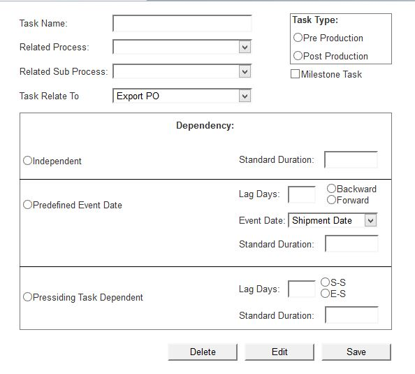

Fig: Task Creation

## Task template Creation

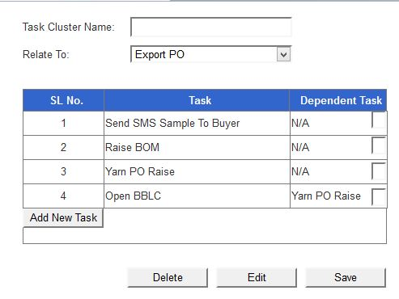

Fig: Task template Creation

## Task Template Attachment

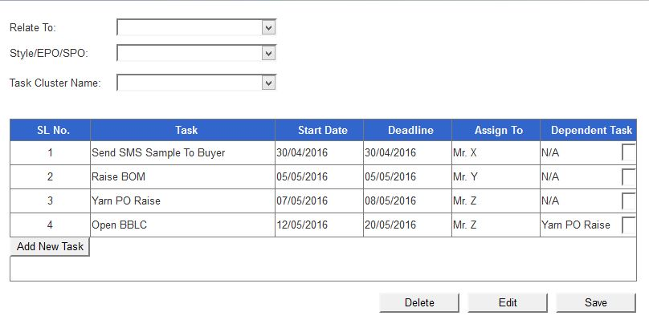

Fig: Inventory Receive

## Task Manager

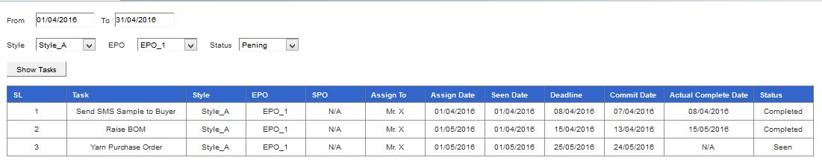

Fig: Task Manager

## My Task

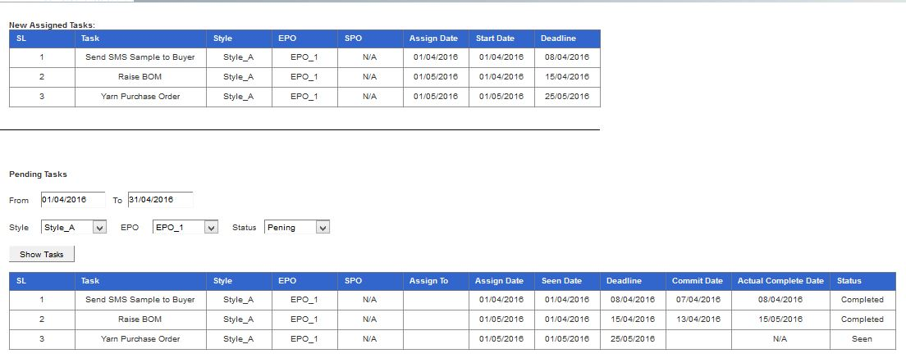

Fig: My Task

## Task Assignee Alteration

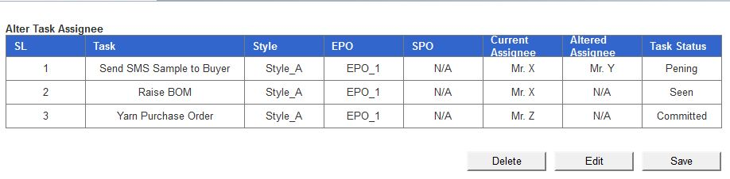

Fig: Task Assignee Alteration